II LITERATURE SURVEY

This chapter focuses on the related works on local positioning systems and formation control systems.

2.1 Local Positioning Systems

Positioning systems fall in to two main branches, global positioning systems and local positioning systems. Global positioning systems(GPS) has become increasingly popular for a couple of last decades for tracking location. It is a precise system depends on satellite based positioning mainly developed for direction finding and navigation. Some of the problems encountered with the usage of GPS systems: (1) the signal from the satellites cannot penetrate to the indoor space so it doesn't perform in such areas, (2) it looses its precision in rich scattering environments such as urban areas[19]. A local positioning system can provide a position information where GPS systems are unavaliable,with the usage of signaling beacons which are placed at the exacltly known locations.

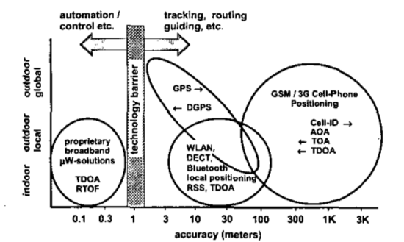

Figure [20]

Figure xx represents an onverview of current positioning systems. Global positioning systems are widely used nowadays and they provide accuracies in the range of 3-30 meters, they can operate outdoor environments with the necessity of radio signals from satellites. Differential GPS systems decrease these accuracy range below 3 meters with the help of additional local static beacons. GSM based solutions have the worst accuracy performance, but they can perform in indoor environments partially. Local positioning systems have the capability of working indoor environments and they have a wide accuray range changing with respect to the implemented topologies and methods.

Local positioning systems has different system topologies illustrated in the Table 1[20].

|  |  |
| --- | --- |
| Concept | Definition |
| Remote Positioning | Measurement from remote site to mobile device |
| Self Positioning | Measurement from mobile unit to usually fixed transponders(landmarks) |
| Indirect remote positioning | Self positioning system with data transfer of measuring result to remote site |
| Indirect self positioning | Remote positioning system with data transfer of measuring result to mobile unit |

Two main topologies are self positioning and remote positioning systems[20]. In self positioning system a mobile device finds its own position with the help of a reference like a starting point or a beacon node with exactly known positions. On the other hand, in remote positioning systems a mobile node locates other objects positions with respect to its own position[19]. These two type of topologies can be converted to each other with the help of a communications structures integrated on the devices to share the result of position measurement and thus indirect remote positioning and indirect self positioning system topologies can be implemented.

2.1.1 Measurement Principles

Angle of arrival (AOA), received signal strength(RSS) and propogation-time based systems are commonly used as three different measurement techniques used in local positioning systems.

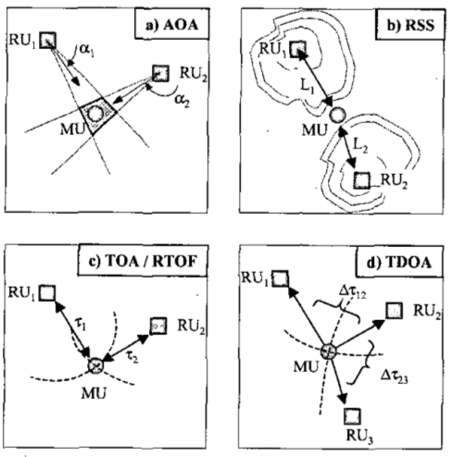

In Angle-of-arrival (AOA) systems use directional antennas to measure the bearing and the angle to the points located at known positions are measured. The position value of device can be calculated with the intersection of several measurement, but the accuarcy is limited by shadowing and multipath reflections of radio signals.

Received signal strength(RSS) systems calculate the distance value by taking the difference of the received signal power from the transmitted power. Some advanced propogation models are required to calculate the distance from the transmission loss in the air to eliminate the multipath fading and shadowing effects[21] .

Time based systems calculates the distance between measuring unit and signal transmitter with the help of propogation time like used in the global positioning systems generally. This process requires a perfect time synchronization between the mobile and stationary units[20].

In this thesis work, we implement a self positioning system in which every agent localize itself with the help of position beacons in the swarm with exactly known positions. The distance from the agents to these beacons in the swarm are assumed to be calculated with the help of a range sensor like a ultrasonic or a lidar sensor.

2.1.2 Trilateration Process

Trilateration process determine the three dimensional coordinates of unknown positions with the help of distance measurement to known position [22]. It is widely used in wireless sensor network topologies and local positioning systems. In theory, it is needed to have at least four beacon nodes to calculte an unknown position in 3D, and at least three beacon nodes to calculate an unknown position in 2D environment. But these worst case numbers are generally not sufficient to estimate an unknown position with a good accuracy due to errors on range calculations and synchronization problems. Figure -xx demonstrates a simple trilateration procees in 2D environment with the help of three position beacons. Suppose a mobile device which tries to estimate its position with the local positioning systems is at the red point in the figure. If it can measure its distance to the beacons named A,B and C with exactly known positions, it will be possible to estimate the unknown position of this mobile device with the same approach used in global positioning systems.

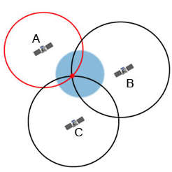

2.2 Formation Control Systems

Formation control approaches can be classified into three basic strategies as leader-following, virtual structure and behaviour based approaches[12]. In leader following strategy, some of the agents in the swarm are the leaders to manage the rest of the swarm to achieve a desired specific task and the rest of the agents act as followers. This approach reduces the formation control problem into tracking control problem of individuals to follow the leader from a desired distance and bearing angle, thus the stability and convergence analysis of the formation can be done with the usage of single tracking controllers of members. Kumar, Fierro .. at [18] proposed a control framwork in which follower agents move along a trajectory afterwords the leader agent with a desired seperation lij(ifade syf2 de) and desired relative bearing angle (ifade). Figure -xx represents a formation control with three agents where R3 is the leader and R1,R2 are the follower agents.

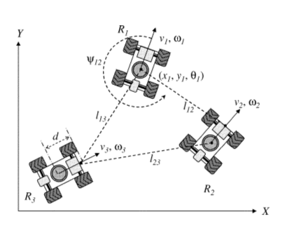

Figure(kendi seklini koy)

In this approach it is hard to apply to gather the agents in a certain shapes. Another drawback is that, determining the seperation and bearing angles for individual agents will be getting harder with the increasing number of agents in the swarm and this strategy is not fault tolerant to the absence of communication between agents.

In virtual structure approach, the formation is composed with a virtual rigid body. Formation control is applied to whole virtual structure and then the individual agent control laws are determined with inverse dynamic solutions[12]. Lewis and Tan proposed a virtual structure based method for formation control in [23] with a bidirectional flow control where robots move to stay in the virtual structure when the swarm is following a trajectory and virtual structure move to fit robots' current positions to compensate the relative errors at the end of that maneuver.

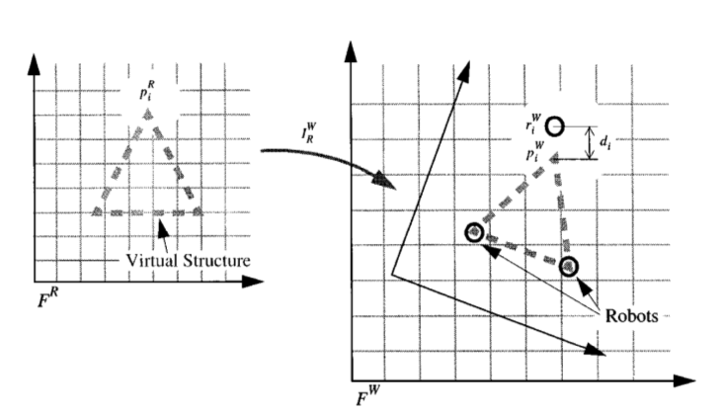

Figure -xx kendi seklini koy

In virtual structure strategy it is east to achieve a coordinated behavior for the group to maintain the formation during a trajectory tracking or a maneuvering, but it is not a suitable strategy to apply a formation control to achieve a certain geometrical shape with the agents in the swarm.

Behavior based strategies model every agents behaviors to achieve specific tasks with swarm. These behaviours may be very simple like randomly walking and avoiding obstacle in the environment or they may be defined very complicated to achieve complex formation shapes with the entire swarm while optimizing the overall energy consumption depend on the implementation of the controller structures. One of the main usage of this strategy is artificial potential field based implementations . Cheng and Nagpal have introduced a robust and self repairing formation control method for swarms in [24]. In this approach, individual control laws for the agents are composed with the artificial forces defined between the agents (to avoid collisions) and between the desired formation shape. This solution provides robustness to the agent losses in the swarm during formation control and the rest of the swarm has the ability to refiil their absence in real time without changing the dynamics and the parameters of the formation controller. One of the main disadvantage of the artificial potential based approaches is that , the control forces applied to individual agents are determined instantaneously in accordance with that agent's and the other agents' positions and they cannot guarantee to optimize the total distance travelled by the agents. In this strategy the solution may converge to the steady state very slow due to absence of generalized goal states for individual agents in the final state of formation.

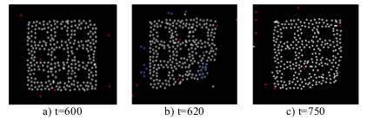

Figure-xx [24]

Another approach is to define mathematical constraints and objective functions to achieve a specific formation shape and controlling the swarm to follow a trajectory while keeping the formation. Kumar and Belta presented an abstraction method of configuration space to a manifold defined as A = G x S where G is a Lie group representing the position and the orientation of the swarm and S represents the shape of the manifold. They provide individual control laws which can be seperately handled to manipulate the lie group “G” to achieve formation tracking and orientation control and to manipulate the shape “S” to achieve different geometrical shapes. Cheah and Slotine proposed a similar method based on objective functions[8]. Common drawback for these researches, they can only implement a limited number of simple geometrical shapes because the desired formation shapes must be identified analyticall to compose the related objective functions or shape manifolds.

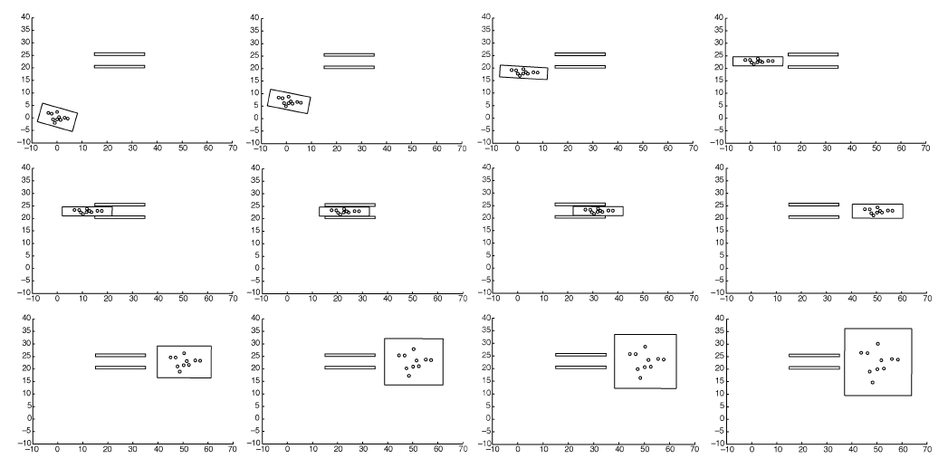

Figure -xx [25]

2.3 Partitioning Complex Geometrical Shapes

This process is used to determine the goal states of the agents in the formation to cover the desired complex geometrical shape. There are some different solutions in the literature including fractal filling of space algorithms, bubble&circle packing algorithms and advancing front algorithms.

Fractals are self similar patterns in all scales of themselves. They are defined with simple rules and they can cover any complex shape in the nature by progressing this simple rules iteratively. This approach is widely used in mesh generating algorithms and filling space problems. Shier and Bourke [26] have introduced a randomized fractal filling of space algorithm. They proposed a fractal based method to cover a given geometrical shape with the desired shapes and they provide the proof of their algorithm is space-filling with the following statements.

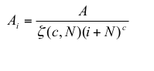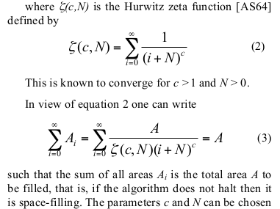

Some of the outputs of their algorithm is given at Figure -xx

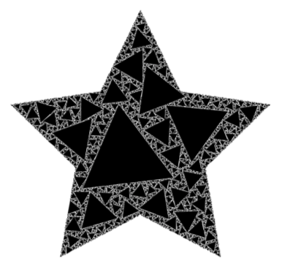

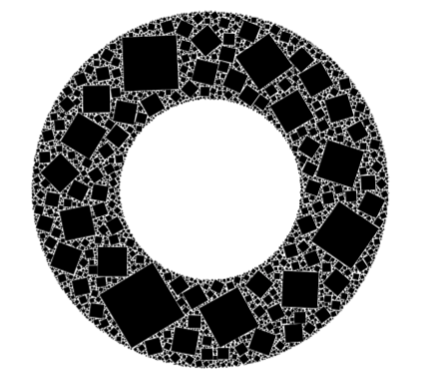

Bubble&Circle packing algorithms are widely used in mesh generation problems in finite element method. The main idea is that the close packong of bubbles mimics a pttern of Voroni tessellation. Corresponding to well shaped Delaunay triangles or tetrahedra which select the best topological connection for a set of nodes by avoiding small included angles[27].

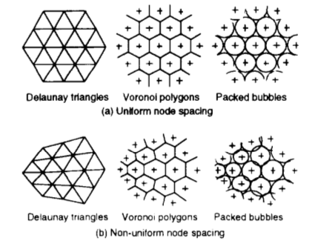

Shimada and Gossard proposed a method based on interbubble forces to provide close packaging of bubbles in desired geometrical shape. This approach is very similar with the one used in formation control of swarms to achieve geometrical shapes. The related interbubble forces are described at Figure – xx.

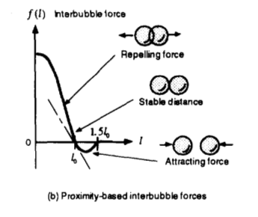

With the help of adaptive population control by removing the excess bubble which significantly overlap their neighbors, they provide an adaptive bubble packing algorithm for mesh generation. A result with a 2D shape is given at Figure -xx

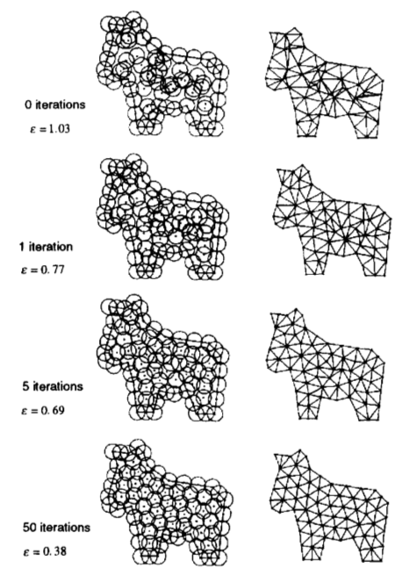

This approach can easily be augmented for different types and number of shapes to partition a complex geometrical shape with regular sets. Basically the resultant solution will be similar to the one used in artificial potential field approach in formation control.

Advancing front methods are one of the alternatives used in mesh generation in literature. In a two dimensional advancing front method, new triangles are added into the domain from the initial front boundary and the front is propogated iteratively between the meshed and the unmeshed region. The initial front is created by the desired outer boundary of the shape and the procedure continues until the given domain is fully meshed.

